Week-01
1(a) Discuss Success and Failure Story
Success Story of Meesho
Meesho is an Indian online shopping platform that enables individuals to start their own online businesses by reselling products. It was founded in 2015 by Vidit Aatrey and Sanjeev Barnwal.
Vidit Aatrey and Sanjeev Barnwal, both graduates from IIT Delhi, recognized the potential of social commerce in India. They saw an opportunity to leverage social media platforms and the network of individuals to create a reselling model.

They developed the initial concept of Meesho as a platform that would connect suppliers, primarily from small and medium-sized enterprises, with resellers who could promote and sell their products through social networks like WhatsApp and Facebook.
Early Stages and Expansion: In 2015, Meesho was launched as a mobile-first platform, targeting women entrepreneurs who wanted to start their own businesses. The founders initially focused on building a network of suppliers and resellers, primarily targeting categories like fashion, accessories, and household products.
Features:
Commission rate, payment cycle, user registration, customer support and marketing tools. The star rating of Meesho is 4.5 out of 5 and the annual income of Meesho in 2023-24 is 7,615 crores.
Success story of Netflix
In just a little over two decades, Netflix has transformed from a humble DVD-by-mail service into a global streaming powerhouse. Today, the company boasts over 200 million subscribers in more than 190 countries.

Netflix begins in 1997 when Reed Hastings, the company’s co-founder, was charged a late fee for a rental copy of Apollo 13. Frustrated with the experience, he came up with the idea for a mail-order DVD rental service that would eliminate late fees altogether. Along with co-founder Marc Randolph, Hastings launched Netflix in 1998, offering a subscription-based model.
In the early years, Netflix faced many challenges, including competition from established brick-and-mortar rental stores like Blockbuster. However, the company was able to differentiate itself by offering a wider selection of DVDs and by avoiding the late fees that had frustrated Hastings in the first place. In 2000, Netflix introduced a monthly subscription plan that allowed customers to rent as many DVDs as they wanted each month for a flat fee.
Features:
User friendly, multi platform support, content library, multiple subscription plans, high quality streaming. Subscription like basic plan M= 199 and Premium M= 649. The star rating of Netflix is 4 out of 5 and annual income is 2,845 crore.

Failure story of Google Wave
When Google first unveiled its new product at the 2009 I/O conference, it seemed like an app like no other. Not only was Google Wave an original centralized workspace and collaboration platform before the remote-work boom, but it also tried to solve many of the same problems we’re still facing today. Google Wave was initially started to answer a simple question: “What would email look like if it were invented today?” However, it was unable to meet even its short-term goals.


What is Google Wave, and where did it come from?
Why aren’t we using this app during quarantine instead of Zoom? Engineer brothers Lars and Jens Rasmussen led the Wave team, who also introduced the mapping product that would eventually become Google Maps. Google Wave was supposed to be a real-time communication platform.
It combined aspects of email, instant messaging, web chat, and social networking to build one simple, in-browser communication application. Google wave was closed in 2010.

Failure story of Shyp
Shyp was one such company to bring on demand service. Shyp sought to remove the hassle of shipping items; their app allowed users to take a photo of the item they wanted to be shipped. The concept was strong enough for the San Francisco-based start-up to eventually raise $62 million in funding to continue its expansion.
The company expanded its services into New York, Los Angeles and Chicago, and introduced new initiatives like its partnership with eBay and a new feature, address-less shipping. And unlike other start-ups that failed to fully deliver the promised services, Shyp did what they said, collecting and shipping material to the required destination.


For all that was going right, there were underlying problems with Shyp’s operating model. A flat fee for pickup and packaging proved a challenge given the wide variance in size of packages that people were sending. Shyp was closed in march 27, 2018. Headquarters of Shyp is in San Francisco and California.

1(c) Enact the importance of ethical practices
Ethical practices standards
Each standard progresses through four levels of impact:

Foundation Level
- At this level you will:
- Take responsibility for your actions
- Act consistently with relevant regulations and law
- Handle personal data and information in a professional manner
- Demonstrate honesty in dealings with others

Associate Level
- At this level you will:
- Make responsibility choices about your work, apply principles and values.
- Consider the purpose and implication of actions, decisions and people practices for all stakeholders.
- Provide explanations and reasons for the choices you make and the advice you provide.
- Demonstrate professionalism and consistency in what you say and do in order to build trust.

Chartered Member Level
- At this level you will:
- Make responsible decisions by considering different ethical perspectives, and finding the best possible way forward for all stakeholders.
- Coach and Influence managers and leaders to consider the implication of their decisions on stakeholders.
- Challenge decisions and actions which are not ethical, explaining the organization risks.
- Encourage transparency in decision-making and communication where possible.

Chartered Fellow Level
- At this level you will:
- Make responsible decisions by balancing different ethical perspectives, and shape how ethics inform wider decision-making and governance.
- Coach and influence senior leaders to consider the ethical impact of their decisions on the short and long-term.
- Take a visible lead in solving ethical dilemmas, considering how they will play out beyond that organization.
- Surface the unsaid in leadership discussions to enable transparency and improved.

Example of Ethics in software engineering:
  - Public
  - Product
  - Judgment
  - Management
  - Client and Employer
  - Profession
  - Colleagues
  - Self

Public
- Software engineers shall act in a manner that is in the best interests of their client and Employer, consistent with the public interest. In particular, software engineers shall, as appropriate.
- Accept full responsibility for their own work.
- Moderate the interests of the software engineer, the employer, the client and the users with the public good.
- Be fair and avoid deception in all statements, particularly public ones, concerning software.

Product
- Software engineers shall ensure that their products and related modifications meet the highest professional standards possible. In particular, software engineers shall, as appropriate:
- Strive for high quality, acceptable cost and a reasonable schedule, ensuring significant trade-offs are clear to and accepted by the employer and the client, and are available for consideration by the user and the public.
- Ensure proper and achievable goals and objectives for any project on which they work or propose.
- Ensure that they are qualified for any project on which they work or propose to work by an appropriate combination of education and training, and experience.
- Work to follow professional standards, when available, that are most appropriate for the task at hand, departing from these only when ethically or technically justified.

Judgment
- Software engineers shall maintain integrity and independence in their professional judgment. In particular, software engineers shall, as appropriate:
- Only endorse documents either prepared under their supervision or within their areas of competence and with which they are in agreement.
- Temper all technical judgments by the need to support and maintain human values.
- Maintain professional objectivity with respect to any software or related documents they are asked to evaluate.
- Disclose to all concerned parties those conflicts of interest that cannot reasonably be avoided or escaped.

Management
- Software engineering managers and leaders shall subscribe to and promote an ethical approach to the management of software development and maintenance. In particular, those managing or leading software engineers shall, as appropriate:
- Ensure good management for any project on which they work, including effective procedures for promotion of quality and reduction of risk.
- Ensure that software engineers are informed of standards before being held to them.
- Ensure that software engineers know the employer’s policies and procedures for protecting passwords, files and information that is confidential to the employer or confidential to others

Client and Employer
- Software engineers shall act in a manner that is in the best interests of their client and employer, consistent with the public interest.
- In particular, software engineers shall, as appropriate: Provide service in their areas of competence, being honest and forthright about any limitations of their experience and education.
- Not knowingly use software that is obtained or retained either illegally or unethically.
- Use the property of a client or employer only in ways properly authorized, and with the client’s or employer’s knowledge and consent.
- Ensure that any document upon which they rely has been approved, when required, by someone authorized to approve it.
Profession
- Software engineers shall advance the integrity and reputation of the profession consistent with the public interest.
- In particular, software engineers shall, as appropriate:
- Help develop an organizational environment favorable to acting ethically.
- Promote public knowledge of software engineering.
- Extend software engineering knowledge by appropriate participation in professional organizations, meetings and publications.
- Support, as members of a profession, other software engineers striving to follow this Code.
Colleagues
- Software engineers shall be fair to and supportive of their colleagues. In particular, software engineers shall, as appropriate.
- Encourage colleagues to adhere to this Code.
- Assist colleagues in professional development
- Credit fully the work of others and refrain from taking undue credit.
- Review the work of others in an objective, candid, and properly- documented way.
- Give a fair hearing to the opinions, concerns, or complaints of a colleague.
- Assist colleagues in being fully aware of current standard work practices including policies and procedures for protecting passwords, files and other confidential information, and security measures in general.
Self
- Software engineers shall participate in lifelong learning regarding the practice of their profession and shall promote an ethical approach to the practice of the profession. In particular, software engineers shall continually endeavor to.
- Further their knowledge of developments in the analysis, specification, design, development, maintenance and testing of software and related documents, together with the management of the development process.
- Improve their ability to create safe, reliable, and useful quality software at reasonable cost and within a reasonable time.
- Improve their ability to produce accurate, informative, and well-written documentation.

Week-02
Overview of SDLC
Development Life Cycle
The Software Development Life Cycle (SDLC) refers to a methodology with clearly defined processes for creating high-quality software in detail, the SDLC methodology focuses on the following phases of software development:
  - Requirement
  - Analysis
  - Planning
  - Software design such as architectural design
  - Software development
  - Testing
  - Deployment
This article will explain how SDLC works, dive deeper in each of the phases, and provide you with examples to get a better understanding of each phase.

What is the software development life cycle?
SDLC or the Software Development Life Cycle is a process that produces software with the highest quality and lowest cost in the shortest time possible. SDLC provides a well-structured flow of phases that help an organization to quickly produce high-quality software which is well-tested and ready for production use.
The SDLC involves six phases as explained in the introduction. Popular SDLC models include the waterfall model, spiral model, and agile model.
So, how does the Software Development Life Cycle work?

How the SDLC Works
SDLC works by lowering the cost of software development while simultaneously improving quality and shortening production time. SDLC achieves these apparently divergent goals by following a plan that removes the typical pitfalls of software development projects. That plan starts by evaluating existing systems for deficiencies.
Next, it defines the requirements of the new system. It then creates the software through the stages of analysis, planning, design, development, testing, and deployment. By
anticipating costly mistakes like failing to ask the end-user or client for feedback, SLDC can eliminate redundant rework and after-the- fact fixes.
It’s also important to know that there is a strong focus on the testing phase. As the SDLC is a repetitive methodology, you have to ensure code quality at every cycle. Many organizations tend to spend few efforts on testing while a stronger focus on testing can save them a lot of rework, time, and money. Be smart and write the right types of tests.
Next, let’s explore the different stages of the Software Development Life Cycle.
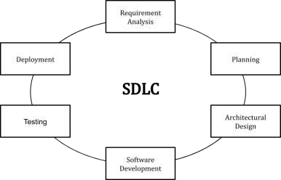

Stages and Best Practices
Following the best practices and/or stages of SDLC ensures the process works in a smooth, efficient, and productive way.

Identify the Current Problems
“What are the current problems?” This stage of the SDLC means getting input from all stakeholders, including customers, salespeople, industry experts, and programmers. Learn the strengths and weaknesses of the current system with improvement as the goal.

“What do we want?” In this stage of the SDLC, the team determines the cost and resources required for implementing the analyzed requirements. It also details the risks involved and provides sub-plans for softening those risks.
In other words, the team should determine the feasibility of the project and how they can implement the project successfully with the lowest risk in mind.

Design
“How will we get what we want?” This phase of the SDLC starts by turning the software specifications into a design plan called the Design Specification. All stakeholders then review this plan and offer feedback and suggestions. It’s crucial to have a plan for collecting and incorporating stakeholder input into this document. Failure at this stage will almost certainly result in cost overruns at best and the total collapse of the project at worst.

Build

“Let’s create what we want.”
At this stage, the actual development starts. It’s important that every developer sticks to the agreed blueprint. Also, make sure you have proper guidelines in place about the code style and practices.
For example, define a nomenclature for files or define a variable naming style such as camel Case. This will help your team to produce organized and consistent code that is easier to understand but also to test during the next phase.
- Code test
“Did we get what we want?” In this stage, we test for defects and deficiencies. We fix those issues until the product meets the original specifications.
In short, we want to verify if the code meets the defined requirements.

Software Deployment

“Let’s start using what we got.”
At this stage, the goal is to deploy the software to the production environment so users can start using the product. However, many organizations choose to move the product through different deployment environments such as a testing or staging environment.
This allows any stakeholders to safely play with the product before releasing it to the market. Besides, this allows any final mistakes to be caught before releasing the product.
Extra: Software Maintenance
“Let’s get this closer to what we want.” The plan almost never turns out perfect when it meets reality. Further, as conditions in the real world change, we need to update and advance the software to match.
The DevOps movement has changed the SDLC in some ways. Developers are now responsible for more and more steps of the entire development process. We also see the value of shifting left. When development and Ops teams use the same toolset to track performance and pin down defects from inception to the retirement of an application, this provides a common language and faster handoffs between teams.
Application performance monitoring (APM) tools can be used in a development, QA, and production environment. This keeps everyone using the same toolset across the entire development lifecycle.

Examples:

The most common SDLC examples or SDLC models are listed below:

Waterfall Model

This SDLC model is the oldest and most straightforward. With this methodology, we finish one phase and then start the next. Each phase has its own mini-plan and each phase “waterfalls” into the next. The biggest drawback of this model is that small details left incomplete can hold up the entire process.
Agile Model
The agile SDLC model separates the product into cycle and delivers a working product very quickly. This methodology produces a succession of releases. Testing to each releases feeds back into that’s incorporated into the next version. According to Robert Half, the drawback of this model is that the heavy emphasis on customer interaction can lead the project in the wrong direction in some cases.
Iterative Model
This SDLC model emphasizes repetition. Developers create a version very quickly and for relatively little cost, then test and improves it through rapid and successive versions. One big disadvantages here is that it can eat up resources fast if left unchecked.
V-Shaped Model
An extension of the waterfall model, this SDLC methodology tests at each stage if development. As with waterfall, this process can run into roadblocks.

Big Bang Model

This high-risk SDLC model throws most of its resources at development and works best for small projects. It lacks the through requirements definition stage of the other methods.

Spiral Model

The most flexible of the SDLC models, the spiral model is similar to the iterative model in its emphasis on repetition. The spiral model goes through the planning, design and bulk up with phases over and over, with gradual improvements at each pass.

1(a) Case Study On Educational Project
Background
A university wanted to develop an e-learning platform to provide online courses and resources to its students. The platform aimed to enhance the learning experience, increase accessibility, and reduce costs.
Requirements Gathering
The development team conducted surveys, interviews, and focus groups with students, faculty, and administrators to gather requirements. The key requirements included:
- User-friendly interface.
- Course management system.
- Online assessments and quizzes.
- Discussion forums and chat functionality.
- Integration with existing student information systems.
SDLC Model
The development team choose the Agile SDLC model, with iterative development, continuous testing, and rapid deployment.

Phases of SDLC

1. Planning
- Defined project scope, timeline, and budget.
- Identified key stakeholders and their roles.
- Developed a project schedule and milestones.
2. Analysis
- Conducted feasibility studies and risk assessments.
- Developed use cases and user stories.
- Created a data flow diagram and entity-relationship diagram.
3. Design
- Developed a detailed design document outlining the architecture, components, and interfaces.
- Created wireframes and prototypes for key features.
- Conducted usability testing and gathered feedback.
4. Development
- Front-end Development:
- HTML5, CSS3, JavaScript.
- Responsive design, accessibility.
- Back-end Development:
- Programming languages: Java, Python.
- Frameworks: Spring, Express.js.
- Database management: MySQL, PostgreSQL.
- Database Design:
- Entity-Relationship Diagram (ERD).
- Database schema, normalization, indexing.
5. Implementation
- Developed the e-learning platform using a combination of open-source and proprietary technologies.
- Conducted unit testing, integration testing, and system testing.
- Deployed the platform to a staging environment for testing and feedback.
6. Coding
- Version Control: Git, GitHub, GitLab.
- Integrated Development Environment (IDE): Eclipse, Visual Studio Code.
- Agile Project Management: Jira, Trello.
- Testing Frameworks: JUnit, PyUnit.
7. Testing
- Conducted alpha and beta testing with a small group of students and faculty.
- Gathered feedback and identified defects.
- Conducted regression testing and ensured that defects were resolved.
8. Deployment
- Deployed the e-learning platform to a production environment.
- Conducted training sessions for faculty and students.
- Provided ongoing support and maintenance.
9. Maintenance
- Monitored platform performance and usage.
- Gathered feedback from users and identified areas for improvement.
- Conducted regular updates and security patches.
Results
The e-learning platform was successfully developed and deployed within the planned timeline and budget. The platform has:
- Increased student engagement and participation in online courses.
- Improved accessibility and flexibility for students with disabilities.
- Reduced costs associated with traditional classroom-based instruction.
- Enhanced the overall learning experience for students.
Lessons Learned
- Agile SDLC model was effective in managing changing requirements and ensuring rapid deployment.
- Continuous testing and feedback were crucial in ensuring the platform met user needs and expectations.
- Ongoing support and maintenance are essential in ensuring the platform remains stable and secure.

2(b) Organize and play games to understand the agile process like, morning wakeup game
- The Marshmallow challenges

The marshmallow challenge was introduced by Tom Wujec. The Purpose of the challenge is to build the Team Coordination, team Work, Patience, Communication and Time Management.


Objectives:
The goal is to build a freestanding structure using limited materials that can hold a marshmallow without it falling.
Requirement Needed for this Challenges Was:
a. 25 sticks of spaghetti
b. 8 Marsh Mallow
- Build the tallest Free-standing Structure in just 20 minutes using no more than 25 sticks of Spaghetti. one yard of String, and 08 Marsh Mallow.
- The structure has to stand firmly on its own, it cannot be propped up, Teams cannot hold on to the Structure when the time runs out. Those touching or supporting the Structure at the end of the exercise will be disqualified.
- The Marshmallow Challenge is a fun and engaging way to build teamwork and problem-solving skills. It's an excellent exercise for corporate teams, students, and anyone looking to boost their collaboration and creativity skills.

- White Elephant Sizing

Overview:
This game is mainly meant for the analyse of the value from user interface according to the mind set of the team members.
- Group the user stories according to their relatives size/efforts taken to build a software.
- Ensure that each teammates gets a chance.
- Learn how user stories are been captured.
- Actively participate in a fun way.
- White Elephant Sizing game mainly is to get the relative size of an agile project and the size of the individual stories before the project starts.
- It mainly gives opportunity to everyone in the team to raise their voice and contribute equally.

Game:
The game is based on food application named Zomato (only an example).

Rules:

If another person is the hall feels wrong can replace the card placed on the boards to different column (by giving a solid reason).

Materials:
- Blackboard
- A set of prepared user interface stories.
- Sticky note pads for attaching the related size/value.

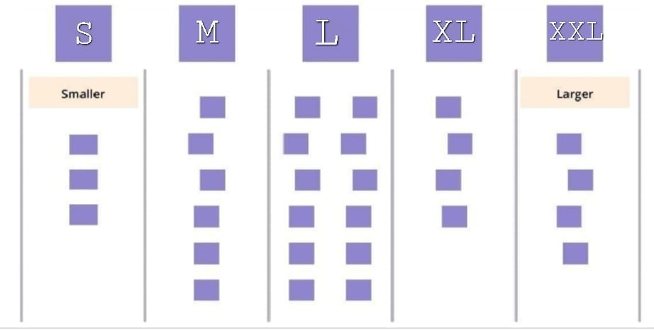
Fig: Elephant sizing

User Interfaces:
- UI 1: Logo interface
- UI 2: Login /Signup Screen
- UI 3: Account details
- UI 4: Menu Screen: Displays all food options.
- UI 5: Customization Screen
- UI 6: Cart Screen
- UI 7: Checkout Screen
- UI 8: Real-time updates on the order status/Location
- UI 9: Settings Screen
- UI 10: Offers
- UI 11: History

Procedure:
- Create five columns on the board and divide it as S, M, L, XL and XXL
- The set of prepared user stories on notes. It will be summary with brief description of the different user stories on different notes (tape or sticky notes).
- After the multiple user screens are explained in game.
- After reading the person only has to assign the card to a column. By giving the explanation.
- It will be continued until the user story cards come to an end.

- Easter Eggs Challenges


A challenge, inspired by this article, that on first sight looks fun and irrelevant, represents in many ways how teams operate, and how that is impacting their productivity. While painting eggs, cutting them out, checking the quality of the delivered product seems extremely easy, the reality shows that even supposedly easy tasks can become difficult and hectic when the participant’s mind set is not right.

Requirements needed for this challenge are:
  - A bunch of papers with unpainted Easter eggs on them.
  - Several boxes of crayons and some scissors.

Objectives:
The challenge is simple: During the challenge the team will be instructed to deliver the painted eggs according to the pre defined requirements , on time.
- Groups of 4 to 5 individuals per team.
- Colour and design the 12 unpainted Easter eggs.
- After colouring the Easter eggs take the scissor and cut in the shape of eggs.
- This activity should be finished by 15 minutes.
- Then which team has finished the challenge in given time with well designed eggs will be the winner.

2(c) Create JIRA (similar tool) account and learn interface
Jira Software:
JIRA is a software development tool used for project management and issue tracking. It is a popular tool among software development teams to plan, track, and release software projects. JIRA provides a centralized platform for managing tasks, bugs, and other types of issues and it helps teams to organize and prioritize their work. The tool integrates with other software development tools and has a variety of customizable features and workflows that allow teams to adapt it to their specific needs. Additionally, JIRA also provides various reporting and dashboard features that help teams to stay on top of their work and make Data-driven decisions.
Jira Features:
- JQL (Jira Query Language).
- Creates advanced Dashboards.
- Add-ons allows customized features, unique, design
- Reports.
Creating an Atlas Sian Account
- Go to the signup page of Atlas Sian and enter the required user credentials asked on the site and then click on the Sign-Up button.
- To complete the setup and login, click the verification link in the email box.
- Set up your Atlas Sian account.
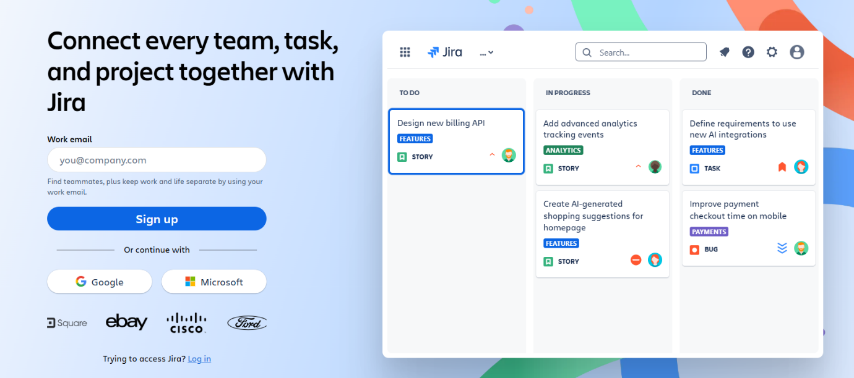
- Click on signup after filling details. The account has been created. The user is automatically redirected to the home page.

Interface of JIRA Software

- Create: You can either create a new epic in agile either use the issues you have created.
JIRA board
2. Plan: Plan mode display all the user stories create for the project
3. Dashboard: Dashboard is the main display you see when you log in to Jira. You can create multiple dashboards from different projects. ΟR multiple dashboard one massive overview of all the mark involved with.
4. Project: A project is a simple collection of issues. You would typically you a project to represent the development work for a product, project or services in Jira software,
5. Roadmap: Road map in Jira software or service are team-level road map useful for planning large pieces of work several months in advance at the Epic level within a single project. Dimple planning and dependency management features help your teams visualize and manage work better together.
6. Backlog: The backlog view lists issues that your team plans to work on (and the backlog. Sprint lists) as well as the issues currently your team's board on you use the backlog issue list to plan work in advance so that team members can quickly jump tasks when they're ready.
7. Active sprint: The Active sprints of the issues that you’re a on the most Scrum board displays team is currently working on. You can create and update issues, and drag and drop issues to transition them through a workflow.
8. Reports: Reports in Jira software are offers critical insights for scrum, Kanban, and any agile methodology in between sprint report burn down chart, release burn down, velocity chart. Control charts etc.
9. Issues: A Jira work in issue represents a single piece of a project, Time tracking allows! Teams to record the amount of time they spend working on issues. Teams can create custom workflows to drive the progression of issues.
10) Releases: A scrum or Kanban board. Releases represent paints in time for your project. They can be used to schedule how Features are rolled out to your customers! a way to organize work that has been completed for the project.
11) Project Settings: Once, You have created a project, you can Configure it to suit the needs of your team or to adopt to a new piece of work. Your team Can use Jira projects to coordinate the development product, track a project, manage a help of a desk, and more

Week-03
Case Study: Agile Ceremonies on Spotify
Background
Spotify, a music steaming service, adopted agile methodologies to improve its product Spotify, a development process. Agile ceremonies played a crucial role in Spotify’s success.
Features
- Logo
- Login/Sign up
- Phone Number
- OTP
- Home Page
- Search Bar
- Music Categories
- Your Library
- Premium
- Create
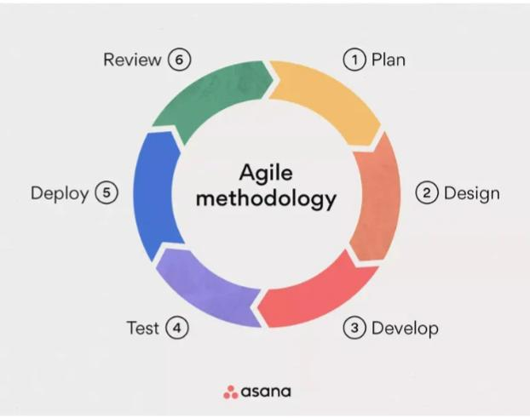
Agile Ceremonies Implemented
Spotify implemented the following agile ceremonies:
- Product Backlog: The first step is to create a list of tasks that need to be completed to achieve the requirement of the stakeholders/Client.
- Sprint Planning: During this stage, the team determines the tasks from the product Backlog that they want to work towards completing during the sprint. Planning for the sprint was done here.
- Sprint Backlog: The tasks discussed during the sprint planning are added to the sprint Backlog.
- Scrum Team: The scrum team usually consists of 5 to 9 members works on the tasks mentioned in the sprint Backlog.
- Daily Scrum: The team will have daily Scrum meeting, which are 15 minute sessions, during which the team members synchronize their activities and plan their activities for the day.
- Sprint Review: After a sprint is completed, a sprint Review takes places. Involving the team, scrum master, product owner and stakeholders, the sprint Review shows what the team accomplished during the sprint. During the meeting, questions are asked, observations are made, feedback and suggestion are also given.
- Product Backlog: At this point, the product owner presents the product Backlog to the stakeholders for suggestions for tasks that can be added in the upcoming sprints, and so on.
- Sprint Retrospective: After the sprint Review, the sprint retrospective takes place. During this meeting, past mistakes, potential issues, and new ways to handle them are identified. Data from here is incorporated when planning the new sprint.
- Increment: A workable output is provided to the stakeholders.
Process:
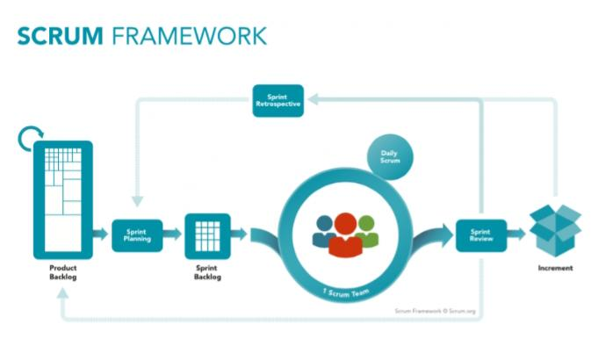
Benefits Realized
Spotify's agile ceremonies brought numerous benefits, including:
1. Improved Communication: Agile ceremonies facilitated open communication among team members, stakeholders, and customers.
2. Increased Transparency: Regular sprint reviews and demos ensured stakeholders were informed about progress and changes.
3. Enhanced Collaboration: Agile ceremonies fostered collaboration among cross-functional teams, ensuring alignment and shared goals.
4. Faster Time-to-Market: Agile methodologies enabled Spotify to release features and updates quickly, responding to changing customer needs.
5. Continuous Improvement: Regular retrospectives helped teams identify areas for improvement, leading to increased efficiency and effectiveness.

Challenges Overcome
Spotify faced challenges while implementing agile ceremonies, including:
1. Scaling Agile: As the company grew, it became challenging to maintain agile practices across multiple teams.
2. Cultural Shift: Adopting agile required a significant cultural shift, as teams needed to adapt to new ways of working.
3. Balancing Priorities: Spotify's teams needed to balance competing priorities, such as delivering new features while maintaining existing ones.

3(b) Play different agile roles. E.g. Product Owner, Business Analyst
The two key pillars for a successful agile project are the Product Owner (PO) and Business Analyst.

PRODUCT OWNER:

A product owner is a role on a Scrum team that is responsible for the project's outcome.
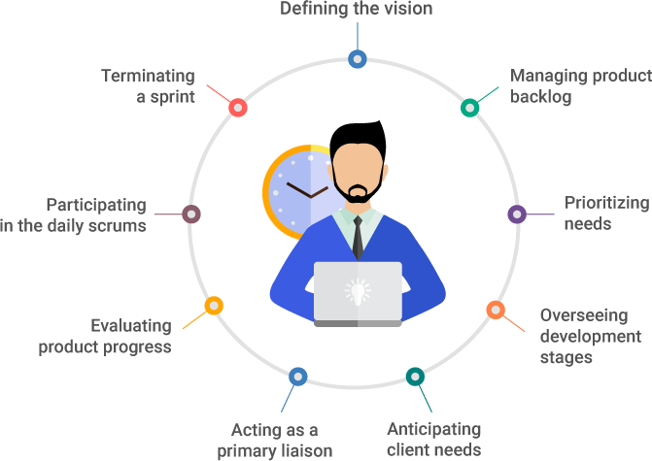
The product owner seeks to maximize a product’s value by managing and making product best and effective.

ROLES AND RESPONSIBILITY OF A PRODUCT OWNER:

- Defining the vision: The agile product owner is the person on the product development team, using their high-level perspective to define goals and create a vision for development projects.
- The product backlog: One of the most important responsibilities for a scrum product owner is managing the product backlog.
- Prioritizing needs: Another key role of the product owner is to prioritize needs. In other words, they must prioritize the triangle of scope, budget, and time, weighing priorities according to the needs and objectives of stakeholders.
- Overseeing development stages: With the vision, strategy, and product priorities set, the product owner should spend a significant amount of time overseeing the actual development of the product. They are a key player throughout each event, including planning, refinement, review, and sprint

SOFT SKILLS NEEDED TO A PRODUCT OWNER:
- Communication
- Technical skills
- Decision Making
- Project Management Skills
- Collaboration

BUSINESS ANALYST:
Agile business is about increasing the deliver of business value of the stakeholders of the project or product being developed.


ROLE OF A BUSINESS ANALYST IN AGILE:
  - Maintain the focus on business value
  - Identify missing requirements
  - Coach the Product Owner (on work)
  - Coach the development team (on business domain)
  - Help define acceptance criteria before work starts
  - Solving Business Problems
  - Looking for Savings and Efficiencies
  - Focusing on Business Development
  - Performance Analysis
  - Competitor Analysis

SOFT SKILLS OF A BUSINESS ANALYST ARE:
Analytical thinking and Problem Solving-solving, creative thinking, systems thinking, learning and decision making
- Behavioral Characteristics - ethics, personal organization and trustworthiness.
- Business Knowledge - business principles & practice, industry knowledge, organization knowledge and solution knowledge.
- Communication Skills - oral communication, written communication and teaching.
- Interaction Skills-facilitation & negotiation, leadership & influencing and teamwork.
- Software Applications - general purpose applications and specialized application.

Week-04
Case Study: Risk Management and Mitigation on Snapchat

Security Risks
1. Use strong passwords: Protect your account with unique, complex passwords.
2. Enable two-factor authentication: Add an extra layer of security to your account.
3. Be cautious with third-party apps: Only grant access to reputable apps.
4. Keep your device and Snapchat app up-to-date: Ensure you have the latest security patches.

Reputation Risks
1. Think before you post: Consider the potential impact of your snaps on your reputation.
2. Use Snapchat's built-in features: Utilize features like the "Here for a Day" disclaimer to add context to your snaps.
3. Be respectful and considerate: Avoid sharing content that could be perceived as hurtful or insensitive.
Operational Risks
1. Regularly back up your data: Save your Snapchat memories to prevent data loss.
2. Use Snapchat's cloud storage: Enable cloud storage to access your snaps across devices.
3. Monitor your account activity: Regularly review your account activity to detect suspicious behaviour.

Compliance Risks
1. Familiarize yourself with Snapchat's community guidelines: Understand what content is allowed and what's not.
2. Respect copyright laws: Only share content you have the rights to or have permission to share.
3. Comply with advertising regulations: Ensure your snaps comply with Snapchat's advertising policies.

Snapchat has faced several risks and security vulnerabilities over the years. Here are some key incidents:

2012-2013: Snapchat's security vulnerabilities allowed users to save photo and video messages indefinitely, despite the app's claim that messages would disappear after being viewed.
2013: Personal credentials of 4.6 million U.S. Snapchat users were made public on the Internet.
2014: The U.S. Federal Trade Commission (FTC) announced a suit against Snapchat, citing six complaints regarding data security and privacy issues.

To mitigate these risks, Snapchat took the following measures:

2014: Snapchat settled charges with the FTC and agreed to update its privacy policy and implement stronger security measures.
2014: Snapchat introduced two-factor authentication to secure user accounts.
2015: Snapchat implemented a bug bounty program to encourage cybersecurity researchers to identify and report security vulnerabilities.
4(b) How to use tools to manage and mitigate risks (e.g. Logic gate, Audit Board etc)
Logic gate:
It is a software where you keep all the information is in one system (logic gate). It includes policies, goals and priorities.

Or
Logic gate’s controls management solutions gives your risks and control owners a break from the disorganized mess of spread sheet email and documents.

Working:
- It will work from single central hub.
- It will according to the industry standard control frameworks (ISCF).

For example:
- Management wants task ‘E’ to be done on priority but the employee gets the email after 2 days about priority.

Advantage:
By using logic gates everyone gets information at real time.

Emails:
Logic gates can be used for emails as well.
- If we find any risk then we can plan & everyone can work on real time.
It’s a rapid session where team will monitor, control assessments, gather evidence and much more, right in the platform. They will continuously collaborate and share information such as tracking, finding or triggering automatic emails when an automatic assessment is kicked off.

Week-05
5(a) Conduct warmup activities to Ignite design thinking
- Riddles

A riddles is a statement, question, or phrase having a double or veiled meaning, put forth as a puzzle to be solved.
Requirements:
- Read a lot of riddles.
- Decide the subject of your riddles.
- Determine how long you want your riddles to be.

Answer:
A teapot
Objectives:
- Riddles help children develop their critical thinking skills by requiring them to analyze information, think logically and find creative solutions to problems.
- Riddles are essentially puzzles or word games that challenge the mind to find a hidden answer. However, riddles are now considered a disappearing form of oral literature.

5(b) Organise and conduct design thinking exercise and games
- Bottle Flip

Water bottle flipping involves taking a plastic water bottle that is partially empty and holding it by the neck of the bottle. Force is applied with a flicking of wrist, with the bottom of the bottle rotating away from the person. If performed successfully, the bottle will land upright.
Requirements:
- We will need a plastic water bottle that is filled between ¼ to ¾ with water. 1/3 is standard.
- We can play from a standing position flipping onto a table or crouching flipping onto the floor.
- Players take turns to try to land a bottle flip by releasing the bottle in a spin and having it land in its base.

Objectives:
- This activity is designed to incorporate student interest in "bottle flipping" and using the activity to demonstrate the scientific principals of gravity, center of gravity and mass.
- Students can explore these concepts using the Scientific Method, making predictions about which bottle they can flip most successfully.

Week-06
6(a) Organize the role play for requirement activities
Facebook
- Facebook is a social networking site that allows users to connect with friends and family online. It was founded in 2004 by Mark Zuckerberg and other Harvard students.
History
- Facebook was originally designed for Harvard students. In 2006, anyone over 13 with a valid email address could join Facebook. The site was the subject of the 2011 film The Social Network.
Features
- Users can share photos, videos, articles, links, events, and groups.
- Users can create and organize communities of interest.
- Users can find and connect with friends and remain updated on their activities.
Facebook collects personal details, publicly shared messages, posted statuses, comments, and likes. Facebook knows who users have added as a friend, friend requests they've received, and who they message.
How to view your information
- Switch to the profile you want to see.
- Tap Menu in the top right of Facebook.
- Tap Settings.
- Tap Accounts Centre, then tap Your information and permissions.
- Tap Access your information.

Requirement for Facebook
- Mobile
- Email ID
- Phone number
- Internet
- Age should be 13 before creating a profile
- Logo
- Login/Sign up
- Account
- Home Screen
- Search Bar
- Profile
- Friends
- Settings
- Log Out
Role Play For Facebook
You: Hi, I'm having trouble logging into my Facebook account.
Facebook: Sorry to hear that! Can you please try resetting your password? You can do this by clicking on the "Forgot Password?" button on the login page.
You: I've already tried resetting my password, but it's not working. I've been getting an error message saying that my account is disabled.
Facebook: Sorry to hear that your account is disabled. Can you please tell me more about what happened before your account was disabled? Did you receive any notifications or warnings from Facebook?
You: I didn't receive any notifications or warnings. I just tried to log in one day and saw that my account was disabled. I've been trying to figure out why, but I haven't been able to get any information.
Facebook: I apologize for the inconvenience. I'm going to need to verify your identity to help you regain access to your account. Can you please provide me with the email address or phone number associated with your Facebook account?
You: My email address is example@email.com.
Facebook: Thank you for providing that information. I'm going to send a verification email to example@email.com. Please check your email and follow the instructions to verify your identity.
You: I've verified my identity and followed the instructions in the email. What's the next step?
Facebook: Thank you for verifying your identity. I'm going to review your account and see what happened. This may take a few minutes. Please be patient and I'll get back to you as soon as possible.
Facebook: I've reviewed your account and it appears that it was disabled due to suspicious activity. However, I've reactivated your account and you should now be able to log in. Please be aware that you may need to reset your password and review your account settings to ensure that everything is secure.
6(b) Identify a problem and prepare requirement document or Epics and user stories

Problem faced by Facebook:
- Facebook has faced many problems, including privacy issues, misinformation, and addiction.
- Privacy issues
- Users have raised concerns about Facebook sharing private messages and contact details without consent.
- Some users have alleged (supposed, or telling without any proof) that Facebook eavesdrops (monitor) on users.
- Misinformation
- Foreign actors have spread false information and sown (putting in) division by interfering with elections.
- Addiction
- Short-term effects of Facebook addiction include increased distraction and reduced productivity.
- Long-term effects include anxiety, depression and Other issues.
How to report a problem on Facebook
- Tap More.
- Scroll to the bottom and tap Help and Support.
- Tap Report a Problem > Something Isn't Working.
- Select the Facebook product you're having a problem with, then describe your problem.
- Add a screenshot from your camera roll.
- Tap Send.
Epic: Facebook:
User Stories
- Login
- Task: As user want, to be able to log in to my account easily, so that I can access my news feed, messages, and other features.
- Posting Update
- Task: As user, want to be able to post updates about my life, so that I can share my thoughts, experiences, and photos with my friends and family.
- Connecting with Friends
- Task: As user, want to be able to easily connect with my friends and family, so that I can see their updates, share my own, and stay in touch.
- Privacy Settings
- Task: As user, want to be able to control who sees my posts and personal information, so that I can maintain my privacy and security online.
- Reporting Issues
- Task: As user, want to be able to easily report issues or problems with the platform, such as spam, harassment, or technical issues, so that Facebook can address them and improve the user experience.
- Account Recovery
- Task: As user, want to be able to recover my account if I forget my password or lose access, so that I can regain control of my account and access my information.
- Ad Preferences
- Task: As user, want to be able to control the types of ads I see, so that I can avoid seeing irrelevant or annoying ads and have a better user experience.
- Group Management
- Task: As user, want to be able to easily manage my groups, including creating, editing, and deleting groups, as well as managing group members and settings.
- Event Management
- Task: As user, want to be able to easily create, edit, and manage events, including inviting friends, tracking RSVPs, and sharing event updates.
- Accessibility Features
- Task: As user, I want to be able to use Facebook's accessibility features, such as text-to-speech, high contrast mode, and keyboard-only navigation, so that I can use the platform comfortably and easily.

6(c) Configure JIRA for the managing the project to solve the identified problem

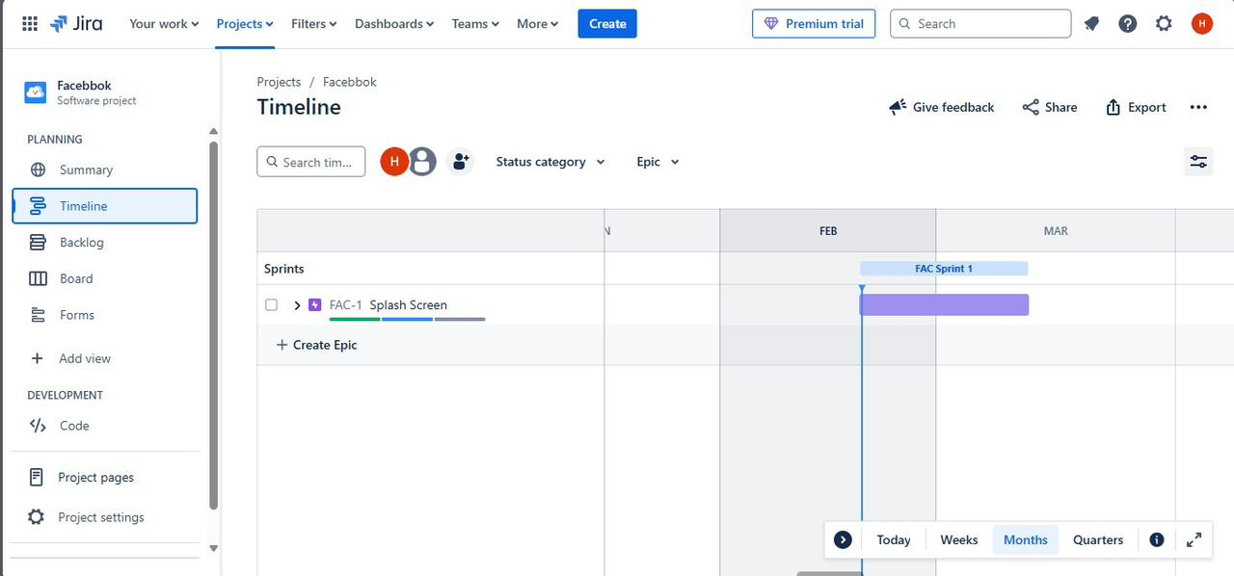
Timeline:

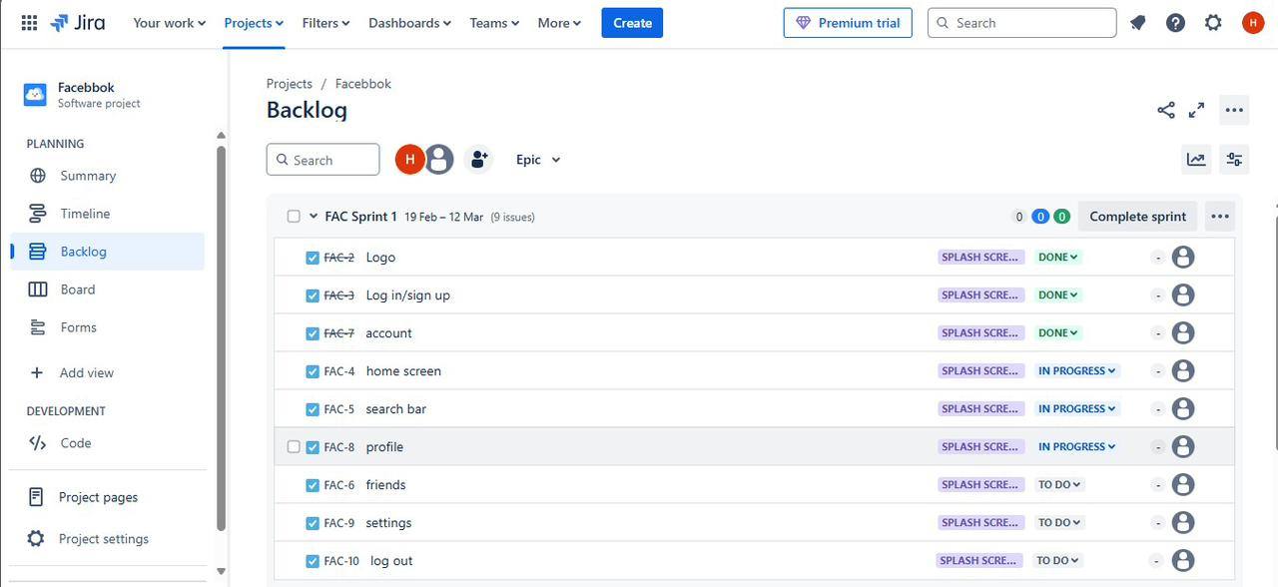
Backlogs:

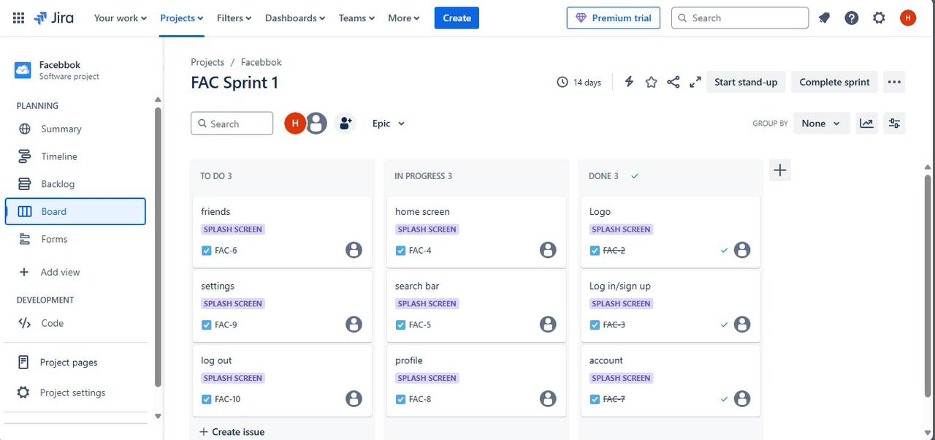
Sprint 1:

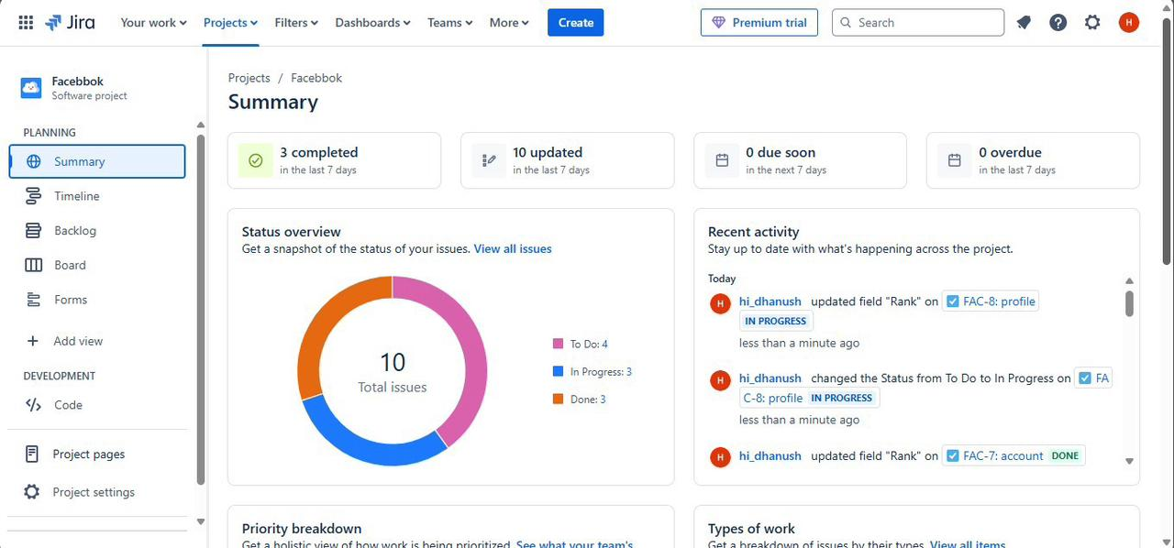
Summary:

6(d) Draw UML diagram for given use case

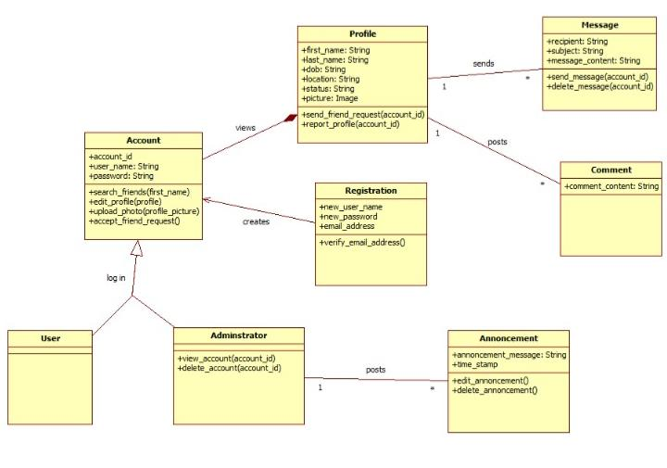
Fig: Class Diagram

Week-07
7(a) Create detailed user stories for the above identified problem
Epic: Facebook
Privacy Issues
1. Data Sharing with Third-party Apps: Facebook allows users to share their data with third-party apps, which can lead to unauthorised data collection and misuse.
- Acceptance Criteria:
- Users are informed about the data being shared with third-party apps.
- Users can control and revoke access to their data for third-party apps.
- Facebook ensures that third-party apps comply with its data protection policies.

2. Data Breaches: Facebook has experienced several data breaches, exposing user data to unauthorized parties.
- Acceptance Criteria:
- Facebook implements robust security measures to prevent data breaches.
- Facebook notifies users promptly in the event of a data breach.
- Facebook provides users with tools to monitor and control their account security.

Misinformation
1. False News Articles: Fabricated news stories designed to deceive or mislead users.
- Acceptance Criteria:
- Facebook's fact-checking partners identify and label false news articles.
- Users are warned before sharing false news articles.
- Facebook demotes or removes false news articles from the News Feed.

2. Deep fakes and Manipulated Media: AI-generated or manipulated content designed to deceive or mislead users.
- Acceptance Criteria:
- Facebook uses AI-powered tools to detect and remove deep fakes and manipulated media.
- Users are warned about the potential for manipulated media.
- Facebook partners with fact-checking organizations to verify the authenticity of media.

Addiction
- Social Validation Addiction: Users become addicted to the constant stream of likes, comments, and shares, which activates the brain's reward system.
- Acceptance Criteria:
- Facebook provides features to help users track and limit their engagement metrics (e.g., likes, comments).
- Users can opt-out of receiving notifications for engagement metrics.
- Facebook promotes content that encourages users to take breaks from the platform.

2. Infinite Scrolling Addiction: The endless feed of content can lead to mindless scrolling, causing users to spend hours on the platform.
- Acceptance Criteria:
- Facebook provides features to help users track and limit their screen time (e.g., time limits, reminders).
- Users can opt-out of infinite scrolling and instead view content in a paginated format.
- Facebook promotes content that encourages users to take breaks from the platform.

7(b) Organize and play planning poker to decide on user points
Planning poker
Planning poker is a popular agile estimation technique used by development teams to estimate the effort required to complete tasks or user stories.
Planning poker is a collaborative estimation technique that uses a deck of cards with numerical values to estimate the effort required to complete tasks. The technique was first introduced by Mike Cohn in 2002.
Planning poker on user stories:
Sl No | User Story | Estimation Points
 | Login | 2 Points
 | Posting update | 3 Points
 | Connecting with friends | 5 Points
 | Privacy Settings | 8 Points
 | Reporting Issues | 3 Points
 | Account Recovery | 5 Points
 | Ad Preferences | 8 Points
 | Group Management | 13 Points
 | Event Management | 13 Points
 | Accessibility Features | 21 Points

Reasons For User Stories:
- Login (2 points)
- Simple task: Login is a straightforward process that requires minimal development effort.

- Posting Updates (3 points)
- Moderate complexity: Posting updates involves creating a new post, uploading media, and handling user input, which requires moderate development effort.

- Connecting with Friends (5 points)
- Higher complexity: Connecting with friends involves searching, sending friend requests, and managing connections, which requires higher development effort.

- Privacy Settings (8 points)
- High complexity: Privacy settings involve managing complex user preferences, data storage, and security, which requires high development effort.
- Reporting Issues (3 points)
- Moderate complexity: Reporting issues involves creating a reporting system, handling user input, and integrating with existing support systems.

- Account Recovery (5 points)
- Higher complexity: Account recovery involves managing password reset, account lockout, and security questions, which requires higher development effort.

- Ad Preferences (8 points)
- High complexity: Ad preferences involve managing complex user preferences, ad targeting, and data storage, which requires high development effort.

- Group Management (13 points)
- Very high complexity: Group management involves managing complex group structures, permissions, and user interactions, which requires very high development effort.

- Event Management (13 points)
- Very high complexity: Event management involves managing complex event structures, invitations, and user interactions, which requires very high development efforts.

- Accessibility Management (21 points)
- Extremely high complexity: Accessibility management involves managing complex accessibility features, such as screen reader support, high contrast mode, and keyboard-only navigation, which requires extremely high development effort.

Week-08
8(a) Create sitemap and wireframe for above created user stories (Tools such as sketch, Adobe XD, Figma etc can be used)
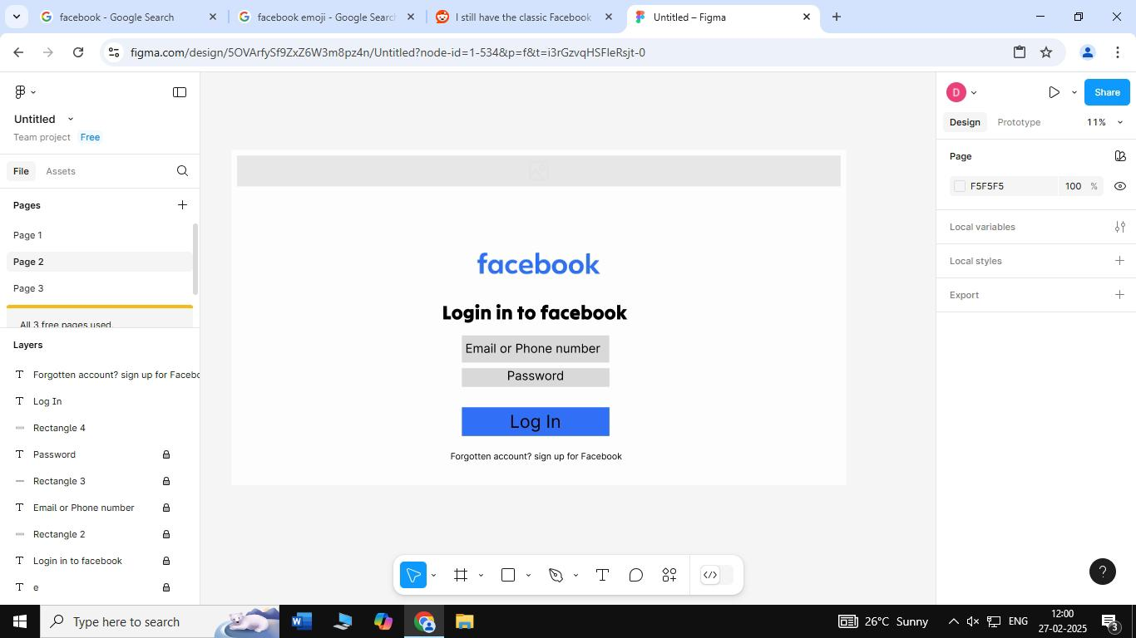
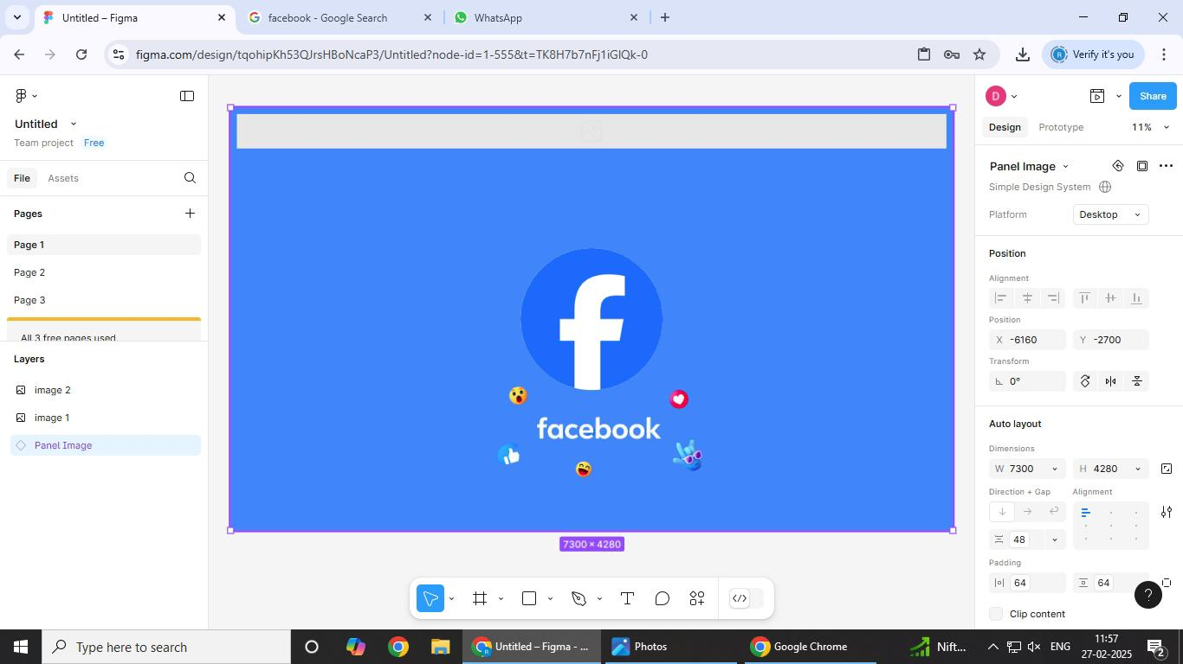
For Desktop:
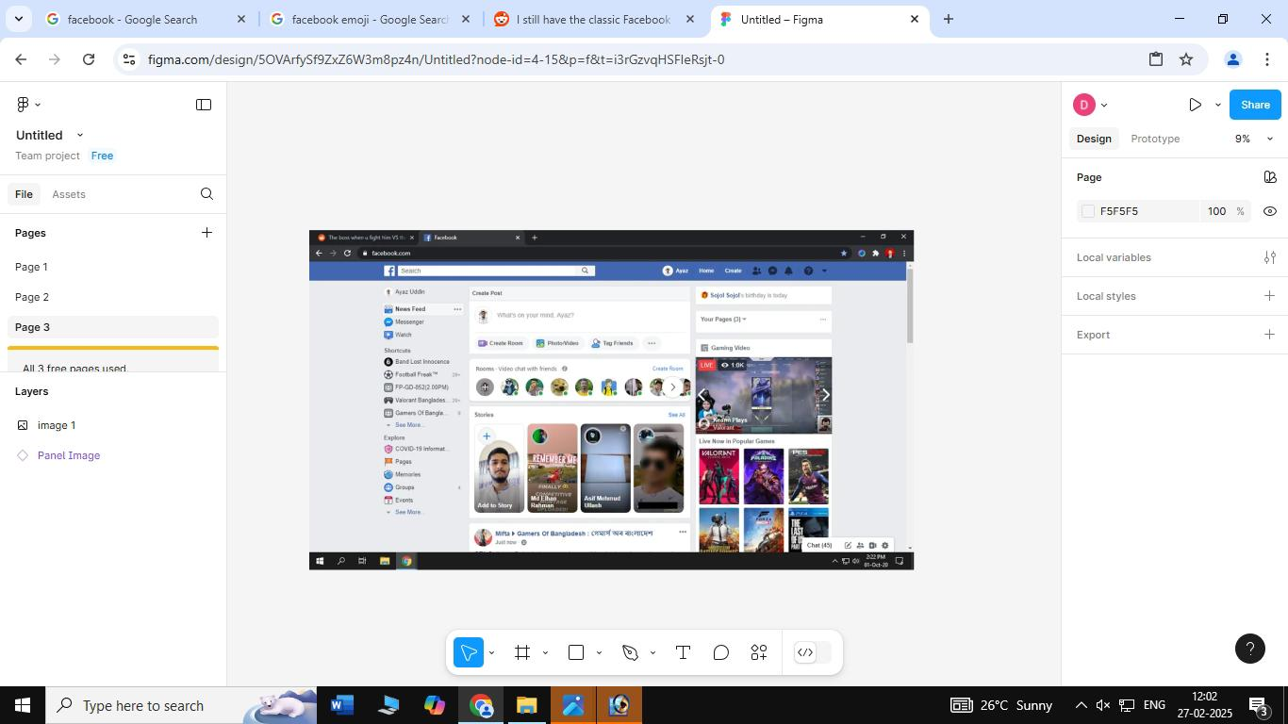

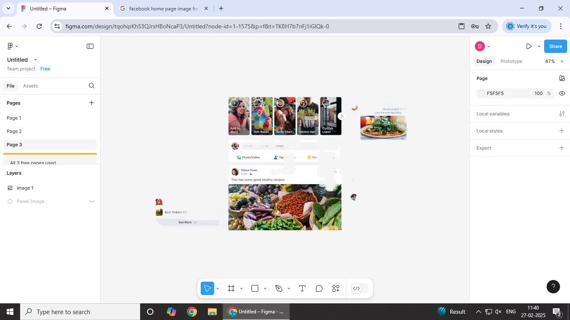

For Mobile:

